

**JAVA PROGRAMME TESTING FOR COM109 ASSINGMENT 2**

*Group Members:*

Cormac O’Neill - B00758943

Toby Killen - B00753973

Contents

Introduction 3

Acknowledgement of known bugs 3

Room for improvement 3

Java Application Test Plan for Practical Assessment 2 4

Screenshot 1 5

Screenshot 2 6

Screenshot 3 7

Screenshot 4 8

Screenshot 5 9

Screenshot 6 10

Screenshot 7 11

# Introduction

Within this document, several tests were carried out a java programme which an object-oriented programme was developed for a user to add, modify current records and delete records from a CSV file containing records. At input stages we considered no invalid, incorrect, extreme and null inputs/data. Below in this document, a test table shows the test name, expectations, real time execution outcome and what action we took if there was any action to take.

## Acknowledgement of known bugs

Whilst testing the programme we came across bug(s) which I will indicate below. The first bug we have is that an action is occurring twice with no intentional code written for this to happen. The main menu would print twice to the console. The screenshot below shows the bug in the console.

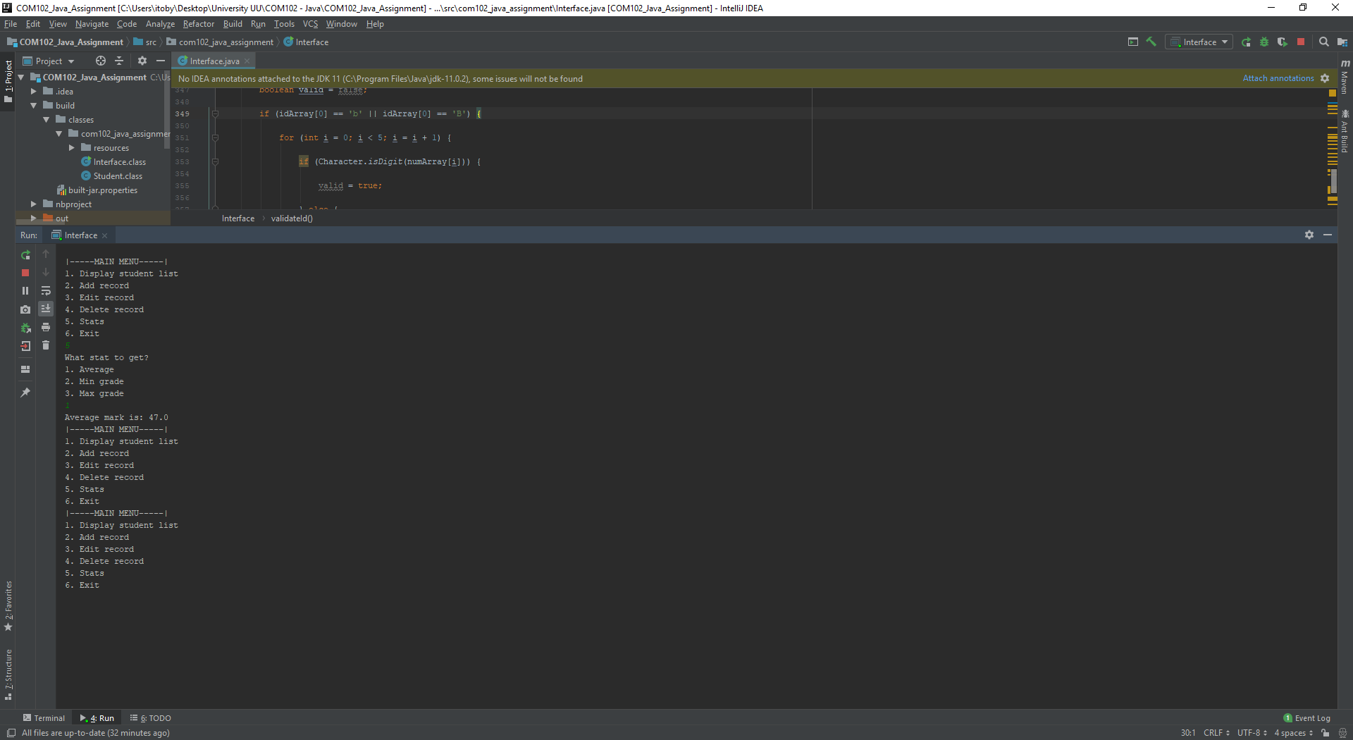

## Room for improvement

Areas to improve the Java programme:

* Using a graphical module to present graphs in a more visual way.
* Allow the user to clear the console.
* Using a GUI module to make a user interface and buttons etc for the programme.

# Java Application Test Plan for Practical Assessment 2

|  |  |  |  |
| --- | --- | --- | --- |
| **Test Name** | **Expectations** | **Real-Time Execution Outcome** | **(If needed) Action Taken** |
| Main Menu & Viewing all records in dataset | Menu loads correctly.  Dataset loads correctly. | The screenshot above shows that the main menu printed to the screen as expected thus this test was carried out successfully and passed. At this stage we were happy to move on. (Screenshot 1) | None. |
| Adding Record | Adding record with correct input validation. | The screenshots above show the results on null,invalid,extreme and incorrect inputs. The programme acted correctly and there for we consided this test a pass and moved on. We programmed the program to do and it sucessfully carried out the task. (Screenshot 2) | None. |
| Editing Record | Editing current record of student in dataset. | The screenshot shows the records being successfully edited. This test passed and no action was needed. (Screenshot 3) | None. |
| Deleting Record | Deleting student record from dataset | The screenshot shows the records deleting correctly. We programmed the program to do and it sucessfully carried out the task. (Screenshot 4) | None. |
| Stats of Record | Viewing statistics of data set. | Programme works out statistics of current dataset. No changes are needed. (Screenshot 5) | None. |
| Exiting Programme | Programming exiting. | Programme exits. No changes are needed. (Screenshot 6) | None. |
| Null values | Input will either return a defined error or loop. | Programme loops or returns a defined error. No changes are needed. (Screenshot 7) | None. |
| Extreme Values | Input will either return a defined error or loop. | Programme loops or returns a defined error. No changes are needed. (Screenshot 7) | None. |
| Invalid | Input will either return a defined error or loop. | Programme loops or returns a defined error. No changes are needed. (Screenshot 7) | None |
| Incorrect | Input will either return a defined error or loop. | Programme loops or returns a defined error. No changes are needed. (Screenshot 7) | None. |

## Screenshot 1

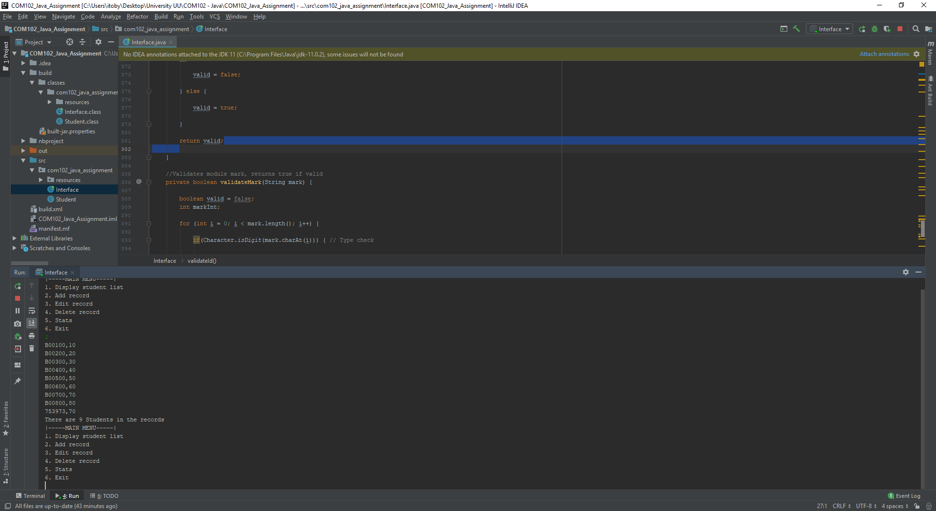

## Screenshot 2

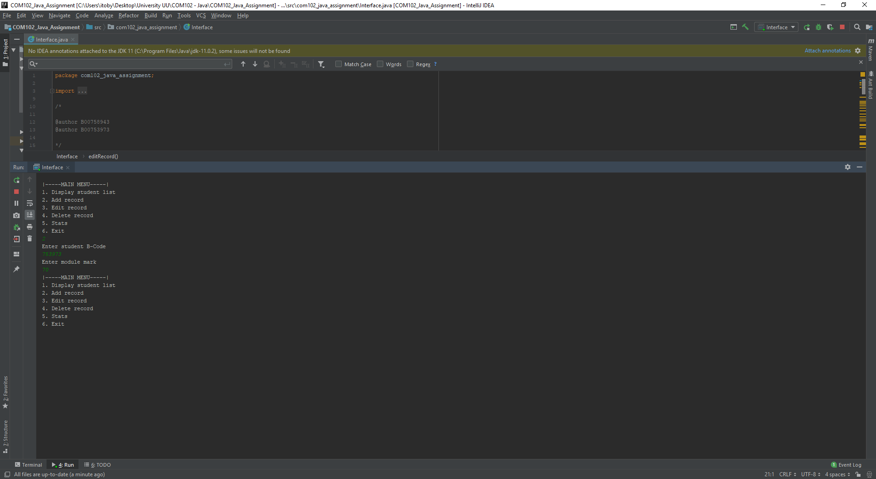

## Screenshot 3

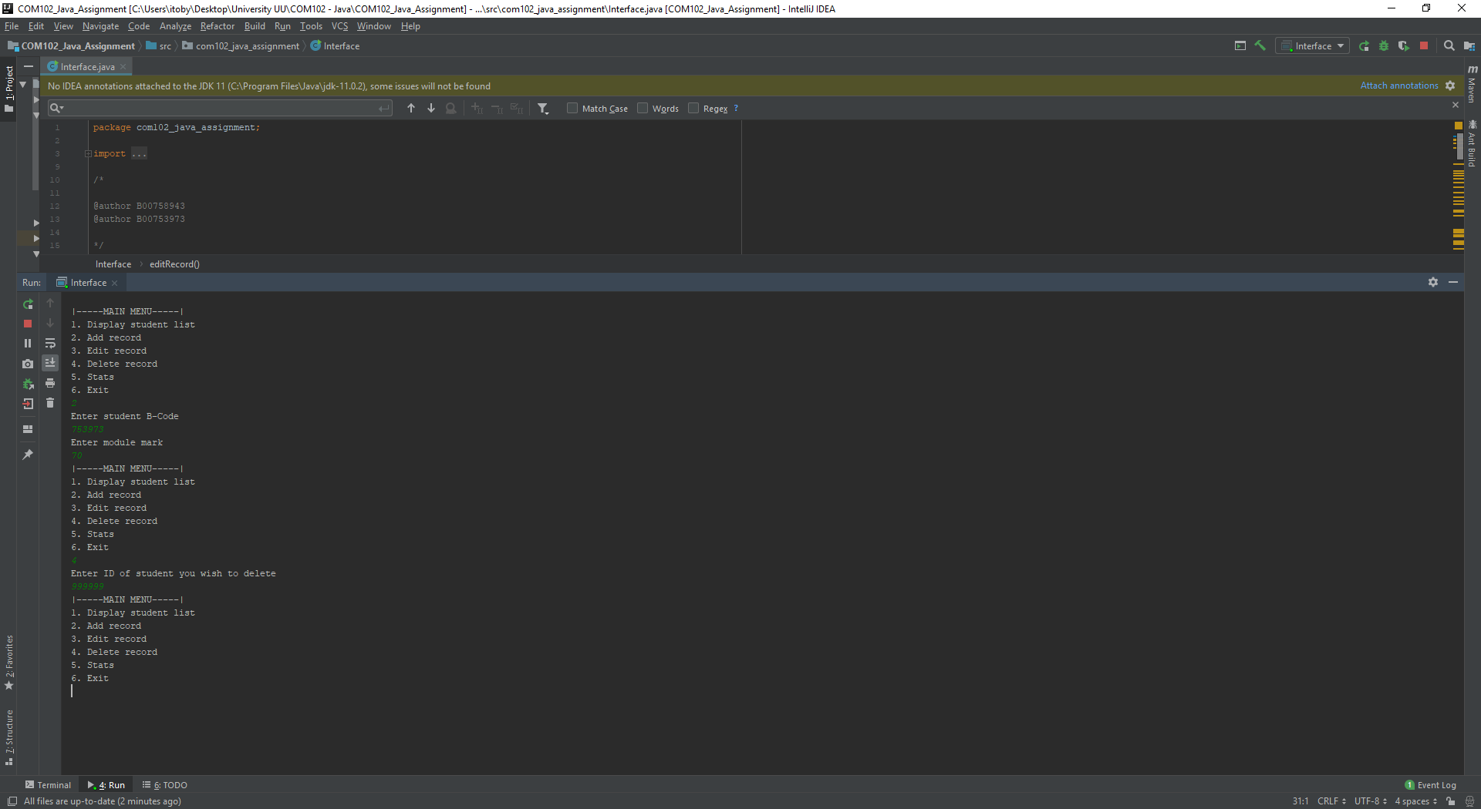

Screenshot 4

## Screenshot 5

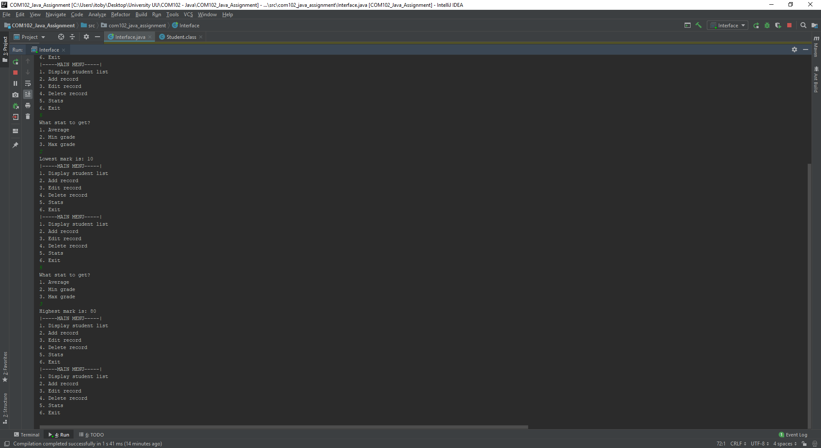

## Screenshot 6

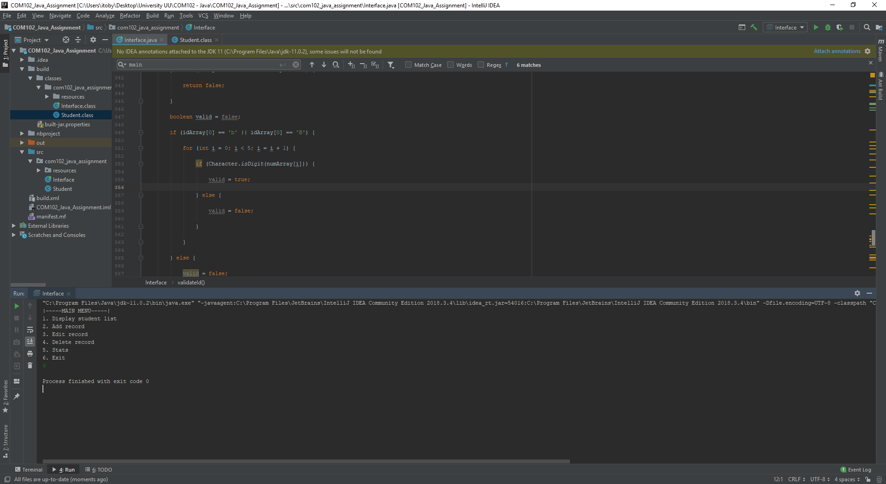

## Screenshot 7

